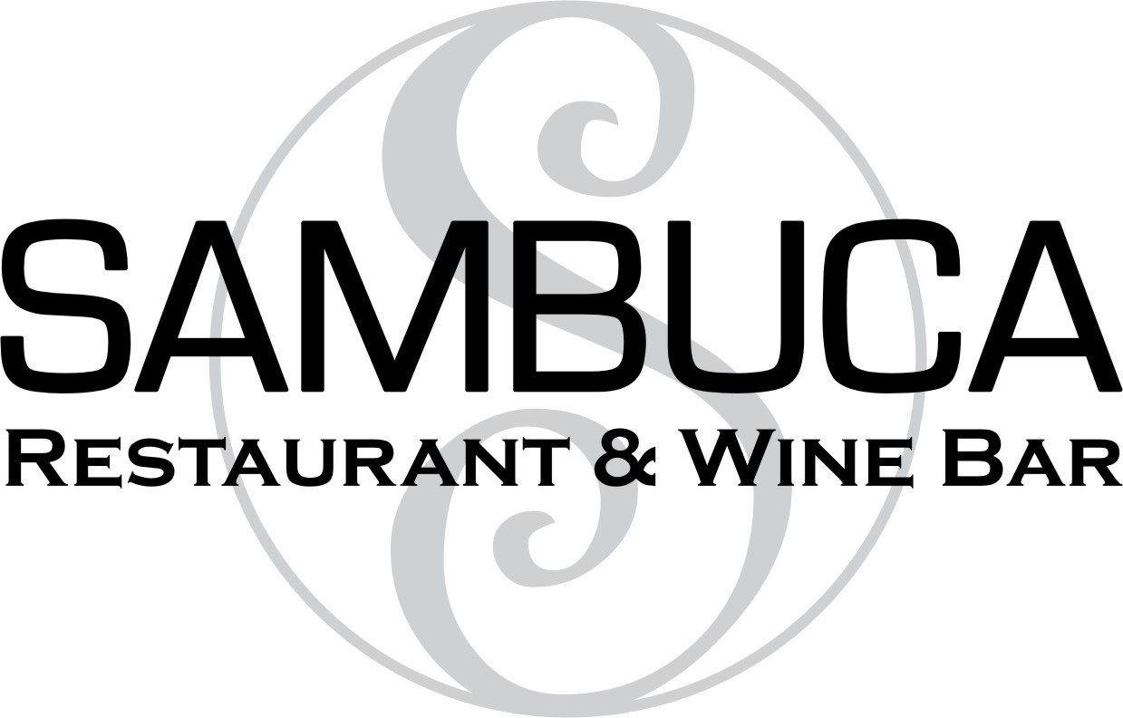

“MEET YOU AT THE MEATBALL BAR”
Salads
11
Sambuca
Tuscan
Chopped
Caesar
Arugula, Fennel
Caprese

Add Chicken 5, Shrimp 7
Sambuca Restaurant & Wine Bar 212.787.5656 20 West 72 Street NY, NY 10023 www.sambucanyc.com Full Dinner Menu & Gluten Free Menu Available Private Party Rooms
Meatballs
12
Skillet of 3
- Blend of Beef, Sausage & Veal
- All Beef
- Veggie
- Gluten Free (Dairy Free,Veggie)
Sliders (2 mini sandwiches)

Spaghetti & one meatball
Add Melted Mozzarella 3

Lite Bites

Grilled Calamari 15
Bruschetta 8
Sizzling Shrimp 15
Marinated Olives 6
Fried Calamari 11
Antipasti Board 14

Pizza

Margherita 13

Caffe

Illy Espresso, Decaf 3.95/4.25

Illy Cappuccino, Decaf 4.50/4.75

Biscotti with Almonds 7.00

